**CLOUD COMPUTING DAY-2 QUESTIONS**

**VM WARE(HYPERVISE-2) STATION**

9.create a Snapshot of a VM and Test it by loading the Previous Version/Cloned VM

Procedure:

1.Before create the clone of given virtual machine.

2.And also store the hardware detiles.

3.Take snapshot1 of clone vm ware.

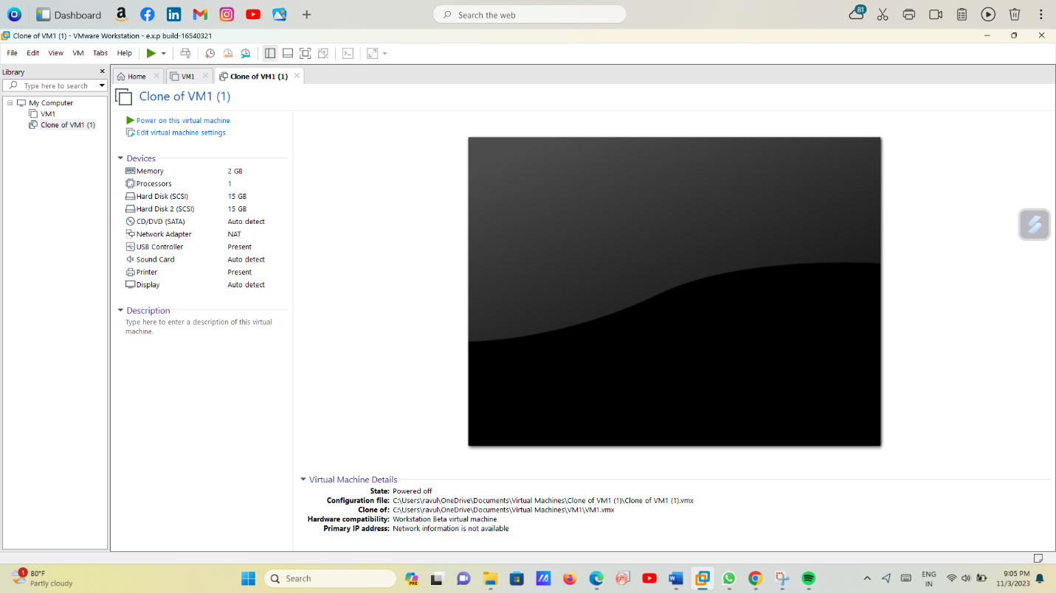

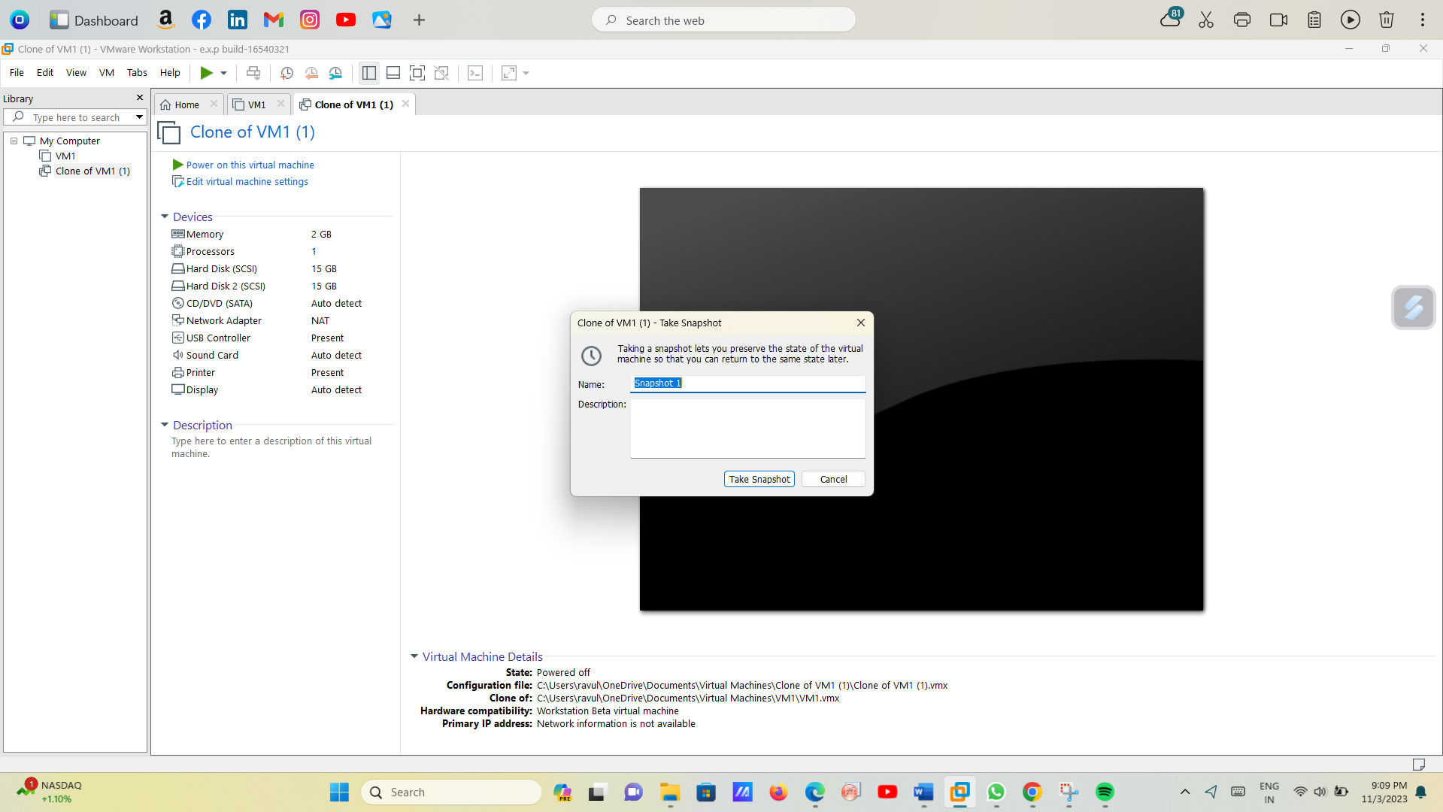

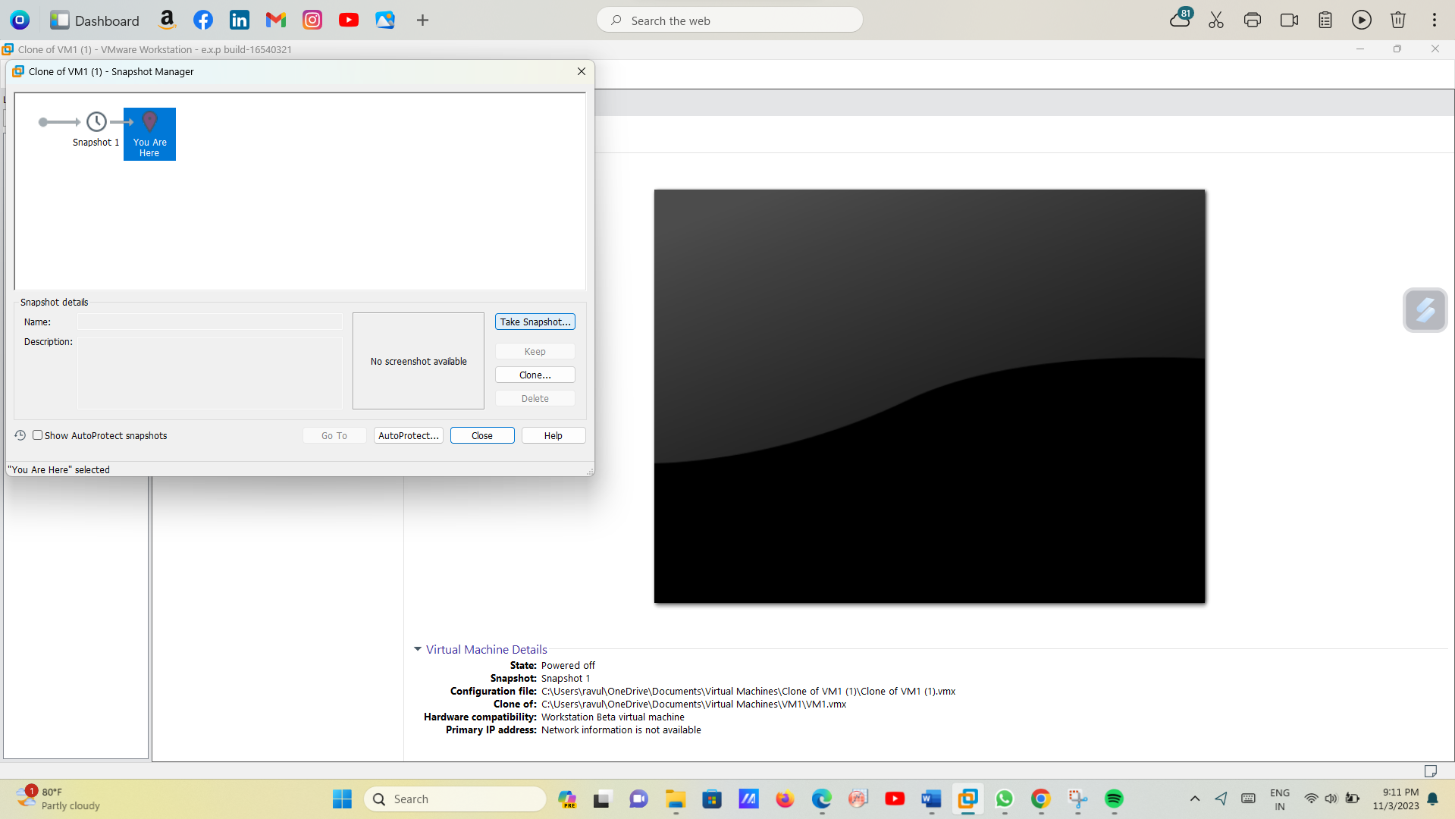

4.After change the hardware functions and take snapshot 2.

5.And after move the previous snapshot to show orginal functions snapshot 1.

6.And after give the warning message yes option.

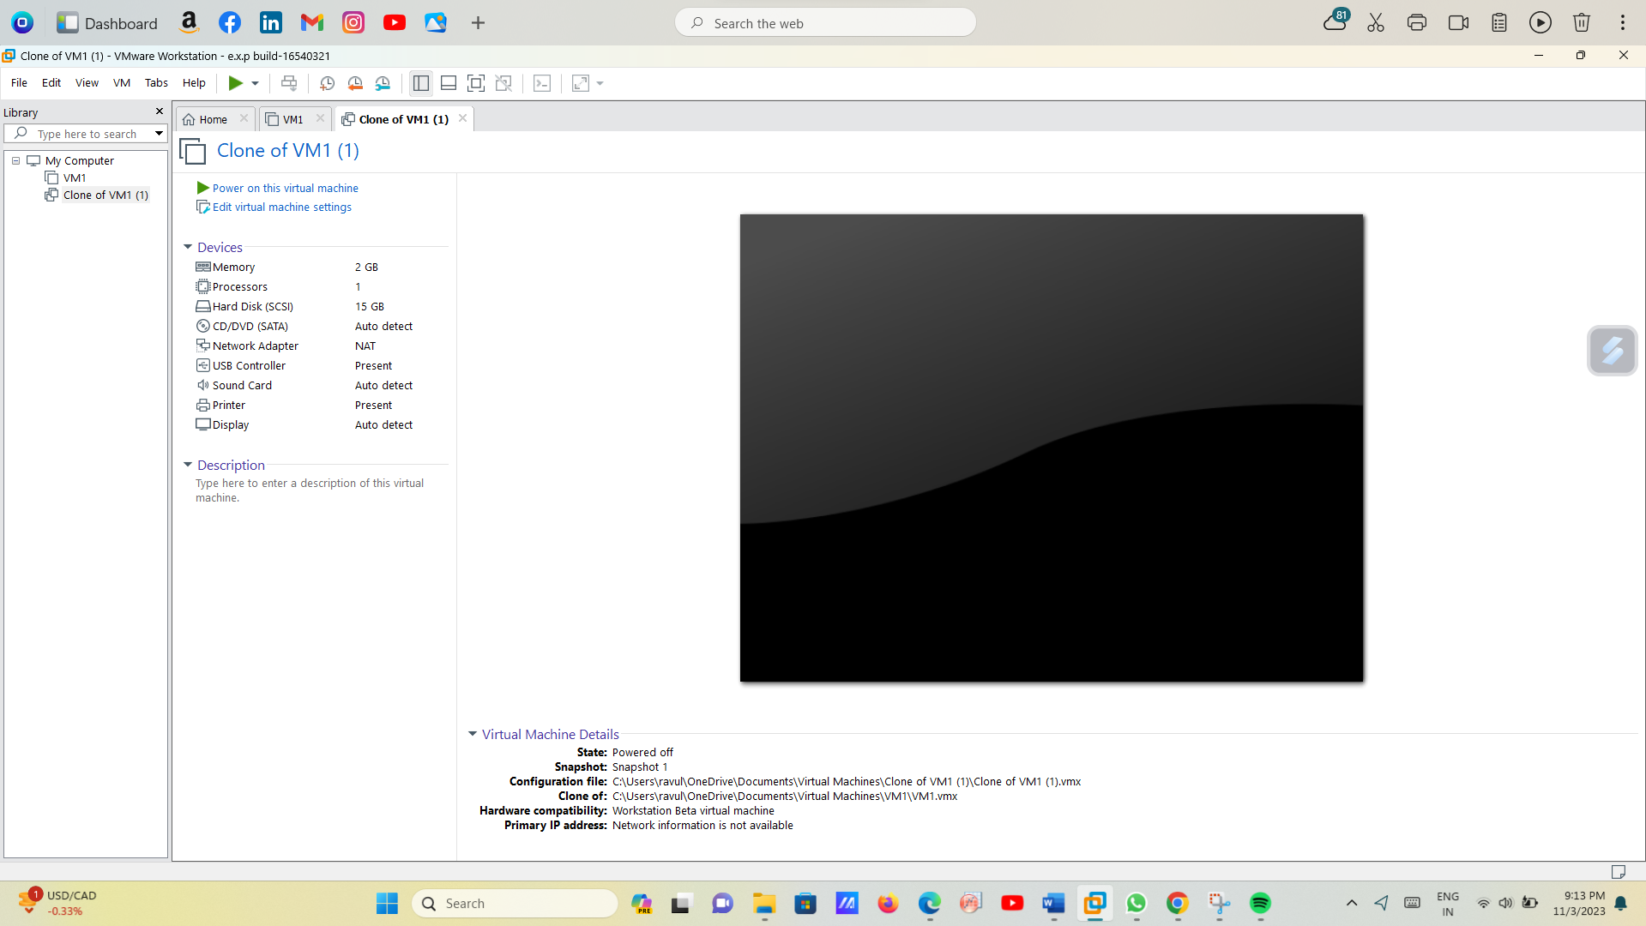

7.This is the original clone vm ware machine (snapshot-1)

